Jira Ticket Statics

**User Manual for Jira Statics Streamlit Application**

**Table of Contents**

1. Overview

2. Features

3. Getting Started

- Step 1: Upload CSV File

- Step 2: Select Date Range

- Step 3: View Ticket Statistics

- Step 4: Highlighting Ticket Status

- Step 5: Download Report

4. Important Notes

5. Troubleshooting

**Overview**

The Jira Statistic application is a Streamlit-based tool designed to analyze JIRA ticket data from a CSV file. This application enables users to upload a CSV file, filter tickets by creation date, and generate detailed reports on ticket statistics.

**Features**

**File Upload**: Users can upload a CSV file containing JIRA ticket data.

**Date Filtering**: Filter tickets based on their creation date.

**Statistics Display:** View comprehensive statistics on ticket statuses.

**Excel Report**: Download the report as an Excel file.

**Getting Started**

**Step 1: Upload CSV File**

1. Upload a File:

- Click the **Upload a CSV file** button.

- Select a CSV file from your local system that contains JIRA ticket data.

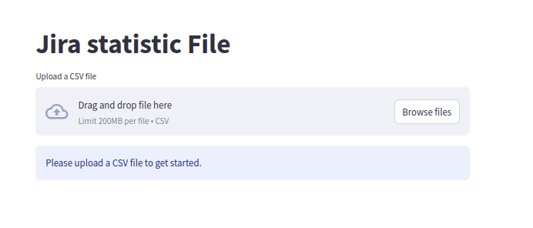

**Step 2: Select Date Range**

1. **Date Input**

- After uploading, a section titled **Select Date Range for Created** Field will appear.

- Use the calendar inputs to select the start date and end date for filtering tickets.

- The default start date is set to 30 days before today, and the end date is set to today .

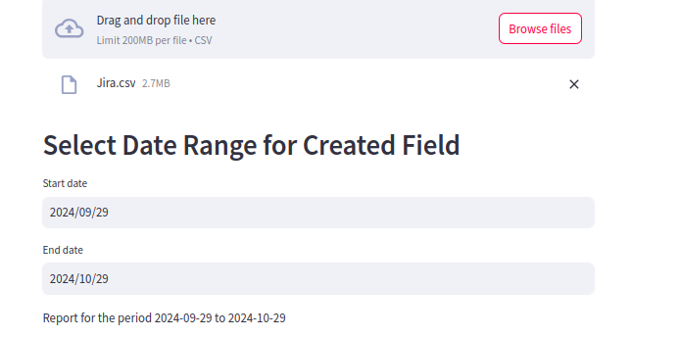

**Step 3: View Ticket Statistics**

1. Statistics Display

- The application will query the data based on your selected date range and display the report.

- If no tickets are found for the selected date range, a message will inform you.

- If tickets are found, you will see the following statistics:

-Total Incident Logged

- Resolved Incidents

- Incidents Under Investigation

- ###A detailed statistic message indicating the current week number of the SOC review report ticket status will also be displayed.##

**Step 4: Highlighting Ticket Status**

- The table of tickets will be displayed with colored backgrounds based on their status:

Closed: Green background

L1 Assigned: Red background

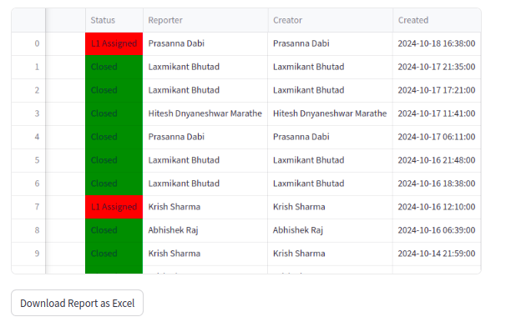

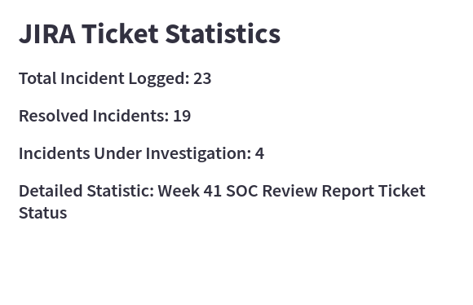

Step 5: Download Report

1. Download Option:

- You can download the report as an **Excel** file by clicking the **Download Report as Excel"button.**

- The report will include the filtered ticket data and will be saved on your device.

**Important Notes**

- Ensure the CSV file contains a column named 'Created' for the date conversion to work correctly.

- The application uses **DuckDB** for querying and filtering the data.

**Troubleshooting**

**Date Parsing Error**: If there’s an error while parsing dates, an error message will be displayed. Ensure the 'Created' column contains valid date formats.

**Empty Data Message: I**f no data is returned for the selected date range, verify that the selected dates correspond to tickets in the uploaded CSV.

**App Link::** [**https://master-elutbqdb4vqtcea4mrp5tf.streamlit.app/**](https://master-elutbqdb4vqtcea4mrp5tf.streamlit.app/)